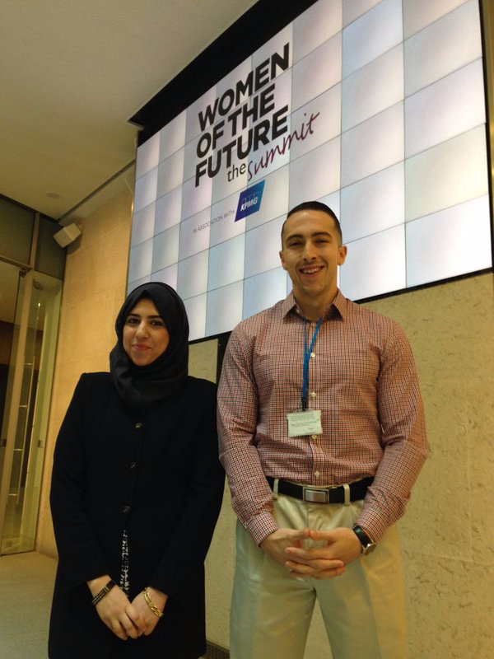

*(Taiba Razwan (Left) and JonRobert “Tat” Tartaglione (Right) at*

*Women of the Future Summit, October 2015, United Kingdom)*

In October, London hosted the first-ever ‘Week of Women’. The Embassy invited two nominees to share perspectives from and about the US. Taiba Razwan who works for Eliminate Domestic Violence (EDV) & advocates for partnership between the US/UK in this field; JonRobert “Tat” Tartaglione, a Rhode Island native with diversity and inclusion expertise and currently earning his Masters of Science in Social Cognition at UCL. Taiba and Tat attended several events during the week with like-minded, young leaders championing gender equality from across the globe. Taiba and Tat share their experience and unique perspectives below.

**Taiba Razwan**

Founder, Eliminate Domestic Violence Youth Council (EDV YC)

@Taiba_EDVYC

As a young, female leader trying to work on global initiatives to eliminate domestic violence, the first taste of global engagement I had was visiting the United States in June 2015 with Baroness Scotland and EDV Global Foundation on a trip organised by the British. It was the first time I was able to experience how the US was dealing with issues such as sexual violence on campus and domestic abuse whilst sharing the ideas we have been working on in Britain. Since my visit, I have sought to find unique ways of undertaking global research with EDV and have often shared my experiences with young peers in EDV Youth Council, who find the information fascinating and inspiring.

Being nominated to attend the Week of Women and Women of the Future Summit was a fantastic opportunity for me to be able to network with leaders and inspirational women from all over the world. Throughout the Summit, I heard global perspectives on gender equality and listened to dialogue that may provide solutions to the world’s most pressing concerns. We met a multidisciplinary network, which included renowned individuals from politics, business, finance and technological sectors, which opened our minds to unique means of collaboration.

Having attended various different events as part of the week, **it was evident that there is a need to develop more global platforms for women to share their experiences with each other**. It is unfortunate that there are few opportunities for women on all levels of public engagement to vocalise their ideas internationally. Especially because it became apparent, over the course of the week, that most of the issues women face are international concerns like access to investment or workplace equality, though differing in level of instance and severity. The solutions too, then, could be applicable globally.

Global conversations are so much richer and open windows for creativity, inspiration and innovation. Opening corridors for international engagement for women, in particular young women, will give them access to international resources, expertise and networks; which ultimately provides a woman the right to engage fully within her local and international community.

**JonRobert Tartaglione**

MSc Candidate, UCL

External Consultant at Cook Ross

“Right this way, ladies!”

Though I am not a lady, at this moment I was fairly certain that the command was referring to me, as well. Several weeks ago, I was one of a handful of men (and I use this phrase as a literal metric and not in the hyperbolic sense) to be extended an invitation to attend the Women of the Future Summit. As such, for one week in late-October I routinely found myself in the company of dozens of the most intelligent, influential, and inspiring women I had ever met. More importantly, perhaps, was that **I also routinely found myself occupying a role I hadn’t often had to navigate, but my female colleagues knew all too well: that of the minority.**

The reason I was invited to serve as a representative at the Women of the Future Summit had a great deal to do with the work I had done at an incredible organization called Cook Ross. Cook Ross is a diversity and inclusion consulting firm that has worked tirelessly for over 25 years to transform organizational cultures into more conscious and humane environments. Cook Ross has become internationally known for the work it does on unconscious bias. As a consultant with Cook Ross, I have had an opportunity to speak with managers and executives of massive organizations about unconscious bias, and I think the similarities between how we react to the term “bias” and how we react to the term “privilege” are telling.

People *do* have privilege, but admitting that you do has become an act marked by reticence and resentment. I fear this is less about ignorance or obstinacy and more about self-preservation. Words are like hammers: depending on the hands they fall into (or the mouths they come out of) they can be used as weapons to harm or tools to teach. When it comes to privilege, I think the word has come to be wielded as a weapon to shame rather than as an opportunity to educate, and as a result we’ve created a situation where people see an admission of privilege as an admission of a character flaw; something to hide or deny. Privilege has developed such an acerbic connotation that we’ve effectively eliminated its utility. If a tree falls in the forest, does it make a sound? Similarly, if nobody is willing to admit to having privilege, do ways to counterbalance said privilege cease to matter?

Privilege comes in many forms, but I think one of the most important domains has to do with inclusion. After spending a week as a man in discussions designed for and geared toward women, I started to realize how hypersensitive you become to subtleties you once overlooked; things I may have once dismissed as insignificant. Referring to the group as a whole as “ladies” was not purposefully done to exclude, nor was there any ill-intent on the part of the individuals saying it. And though I may not have taken it personally, I *noticed* it. I noticed how it made me feel. I’ve consistently found myself included when gender-exclusive terms like “gentlemen” and “businessmen” are tossed around, and so it’s never been something I’ve seen as a problem. I now realize the power that subtle yet omnipresent inequities like linguistic cues can have. **It took me just a week of spending time as a member of a minority group to realize how the way we use language can signify default inclusion for some and default exclusion for others.**

We need to start recognizing that notbeing purposefully excluded is *not* the same as being included. **Offering women a seat in the boardroom while continuing to address the group as “gentlemen” is problematic.** As a man myself it’s rarely something I’ve ever noticed, and in that way I’ve been *privileged*. But now I can see: what good is being offered a seat at the table if it’s constantly reinforced that I don’t *quite* belong?

I can’t overstate the immense respect I have for each and every woman I met during the weeklong experience. They were leaders, innovators, and inspirations in every sense of the word, and they’ve achieved all of this despite constantly fighting against what is often an imperceptible (from the point of view of a man like myself) current of tacit exclusion, ambivalence, and resentful inclusion. I recognize that I am privileged enough to not have to fight against that current as they do, and it is only through that recognition that I can do what I can to help calm the waters.